INDIAN INSTITUTE OF TECHNOLOGY KHARAGPUR



Department of Electronics & Electrical Communication

Engineering

M.Tech. First Year

Vision and Intelligent Systems

(VIS)

EC60064-Biomedical System Engineering and Automation

Assignment 4

Submitted by

Suraj Kumar

Roll No. = 22EC65R14

**Question 1**

1. Prepare a signal that contains the sum of one sine wave of frequency **70 *Hz***and one cosine wave of frequency **80** Hzof equal amplitude.Let the sampling rate be1 ***kHz.***

(a)Compute the power spectrum of the signal with :-

1) rectangular window of duration 0.5s and 1.5s.

2) Hanning window of duration 1.0s and 2.0s.

(b) Calculate PSD Parameters – Variance, Skewness and Kurtosis

Note:-

To obtain the power spectrum, take the FFT and square the result. Compare the spectra obtained in parts (1) &(2) and comment upon their similarities and/or differences. In order tovisualize the differences clearly, use 2,048-point FFTsand plot the logarithm of the magnitude-squared spectra with an expanded scale from 0 to 100 *Hz* only.

**Outputs**

Original Signal: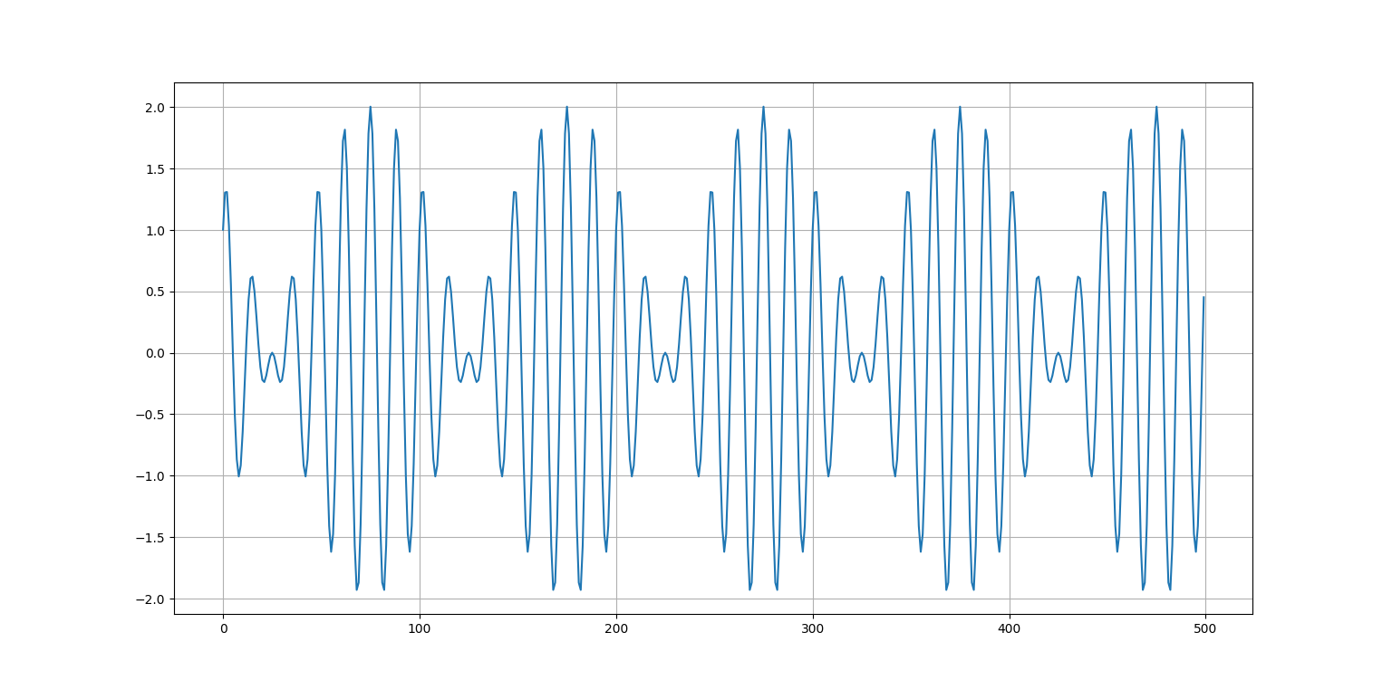

With Rectangular Window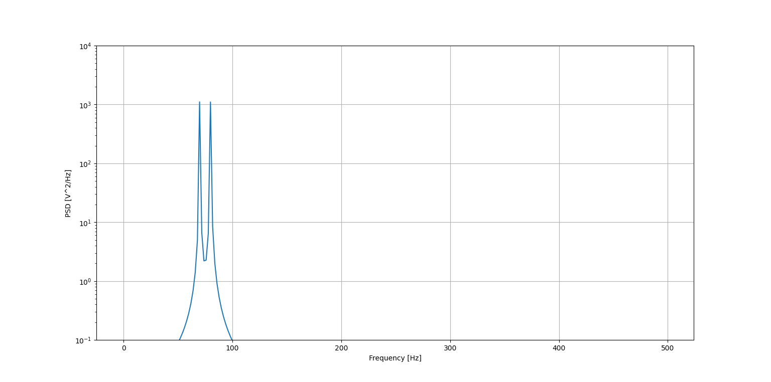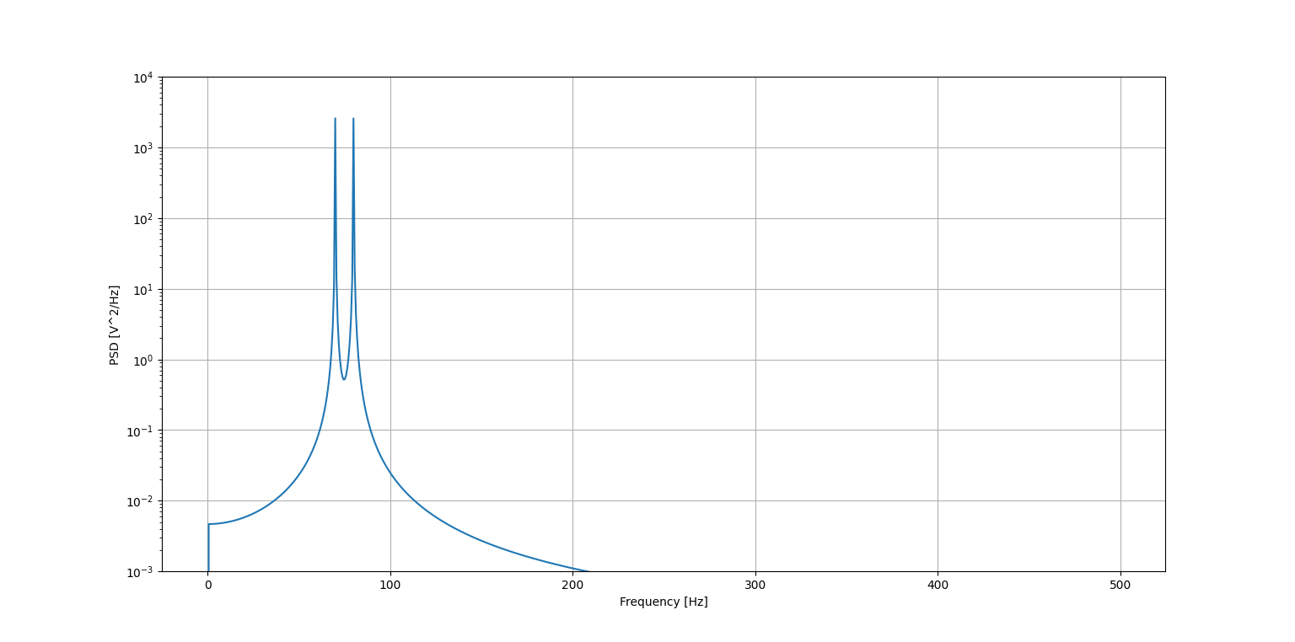

With Hanning Window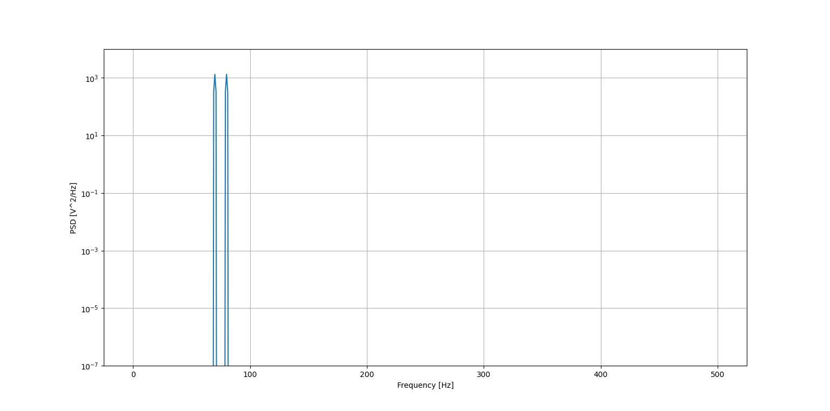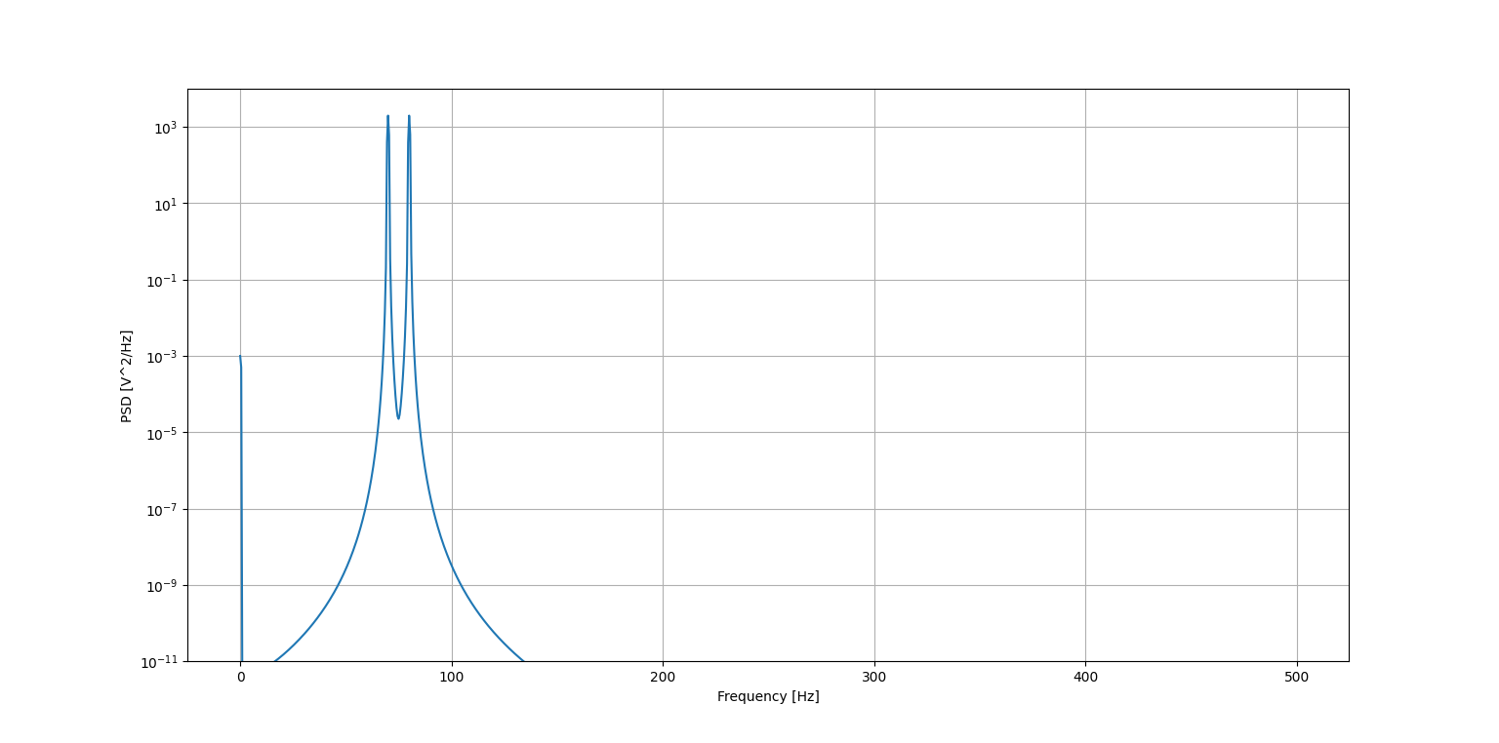

**variance of first fft = 98.36279948478413**

**kurtosis of first fft = 120.49140970490687**

**skewness of first fft = 11.067095578905004**

**--------------------------------------------**

**variance of second fft = 132.84060223847354**

**kurtosis of second fft = 370.4563787065348**

**skewness of second fft = 19.298352029432493**

**--------------------------------------------**

**variance of Third fft = 88.99599524793435**

**kurtosis of Third fft = 194.7765476156739**

**skewness of Third fft = 13.574123912151512**

**--------------------------------------------**

**variance of Fourth fft = 94.45022924983537**

**kurtosis of Fourth fft = 386.85710377770874**

**skewness of Fourth fft = 19.08822365965011**

**Observations:**

1. Hanning window PSD is more sharp and hence it is more smoother than Rectangular Window
2. With increase of the window length the higher frequency component increases and hence sharpness increases

**Question 2**

1. Compute the PSDs of two EEG signals eeg1.dat and eeg2.dat using Welch’s procedure. Study the changes in the PSDs derived with following window
2. Rectangular window
3. Hanning window
4. Blackman window

with variations in the window width (50, 150, 250), the number of segments (3, 5, 10) averaged. Compare the results with the PSDs computed using the entire signal in each channel. Discuss the results in terms ofthe effects of the procedures and parameters on spectral resolution and leakage.

**Outputs:**

Original Signal 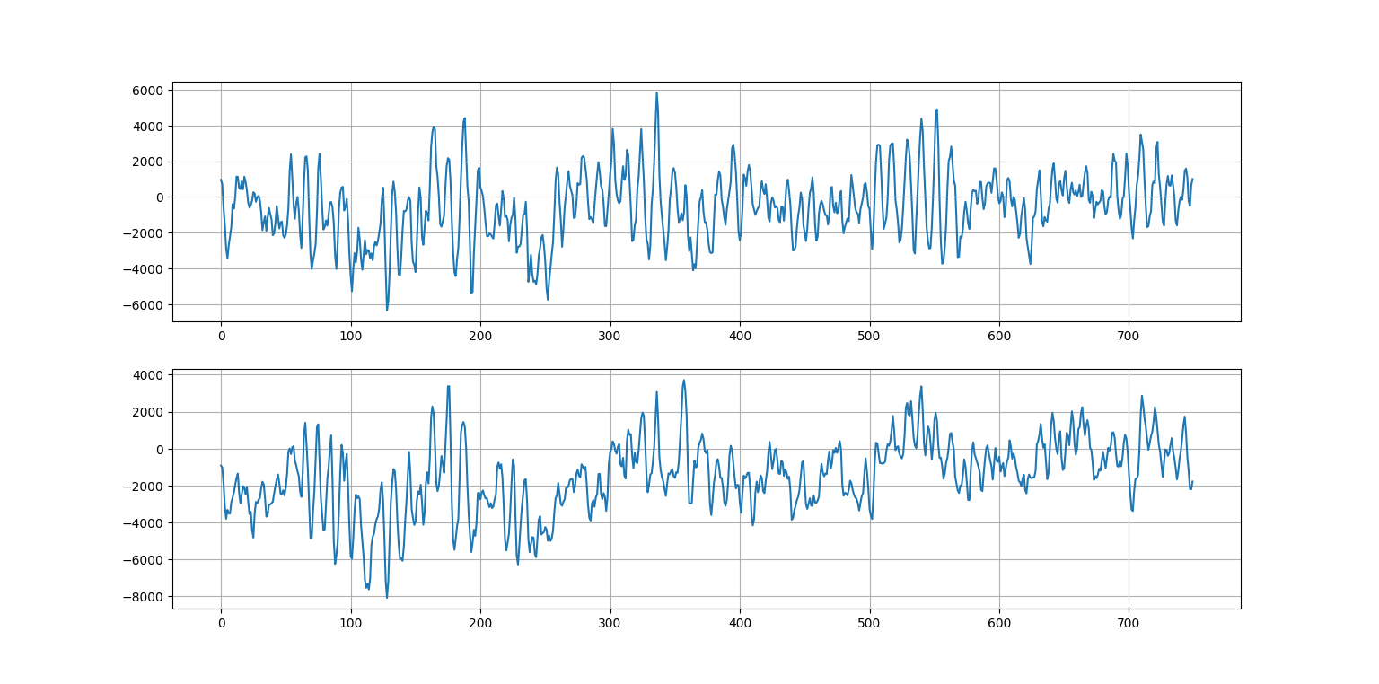

EEg1 with rect window, hanning window and blackman window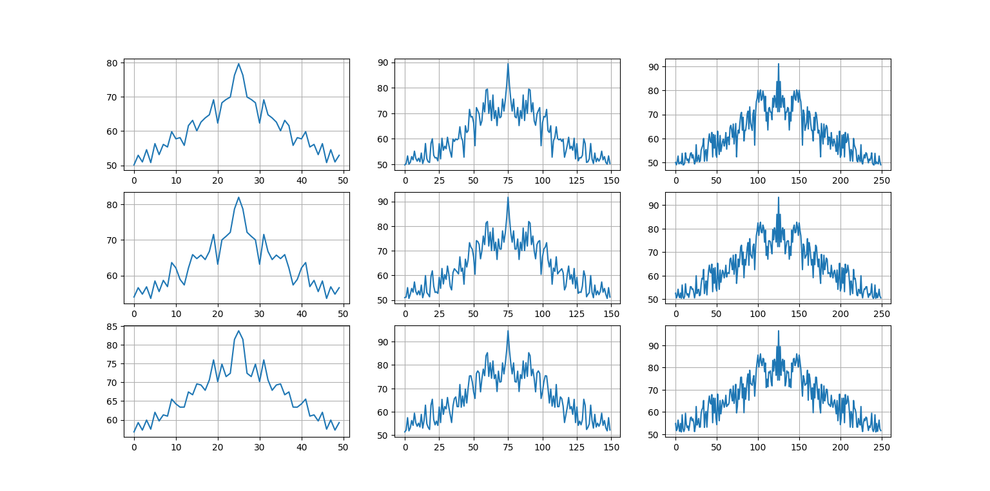

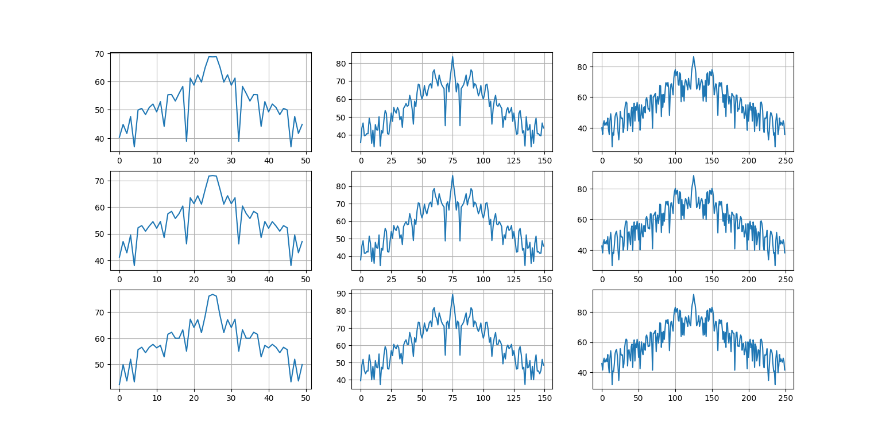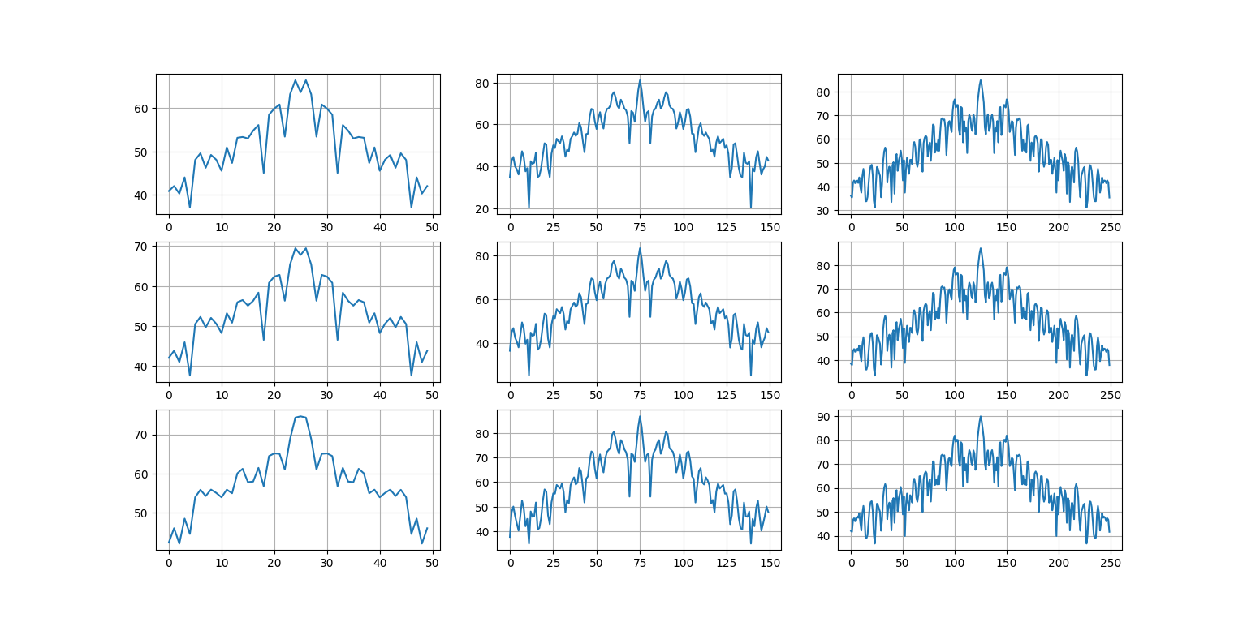

EEg2 with rect window, hanning window and blackman window 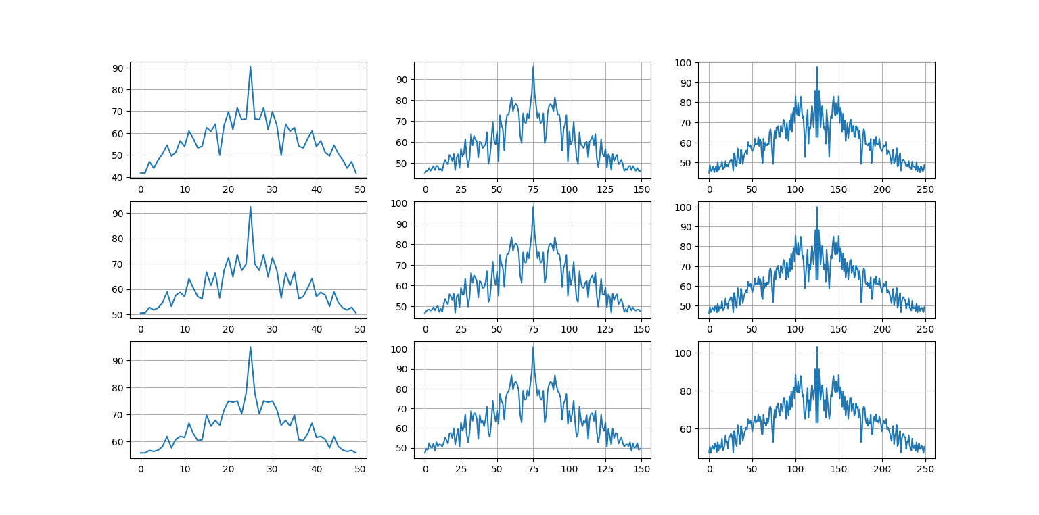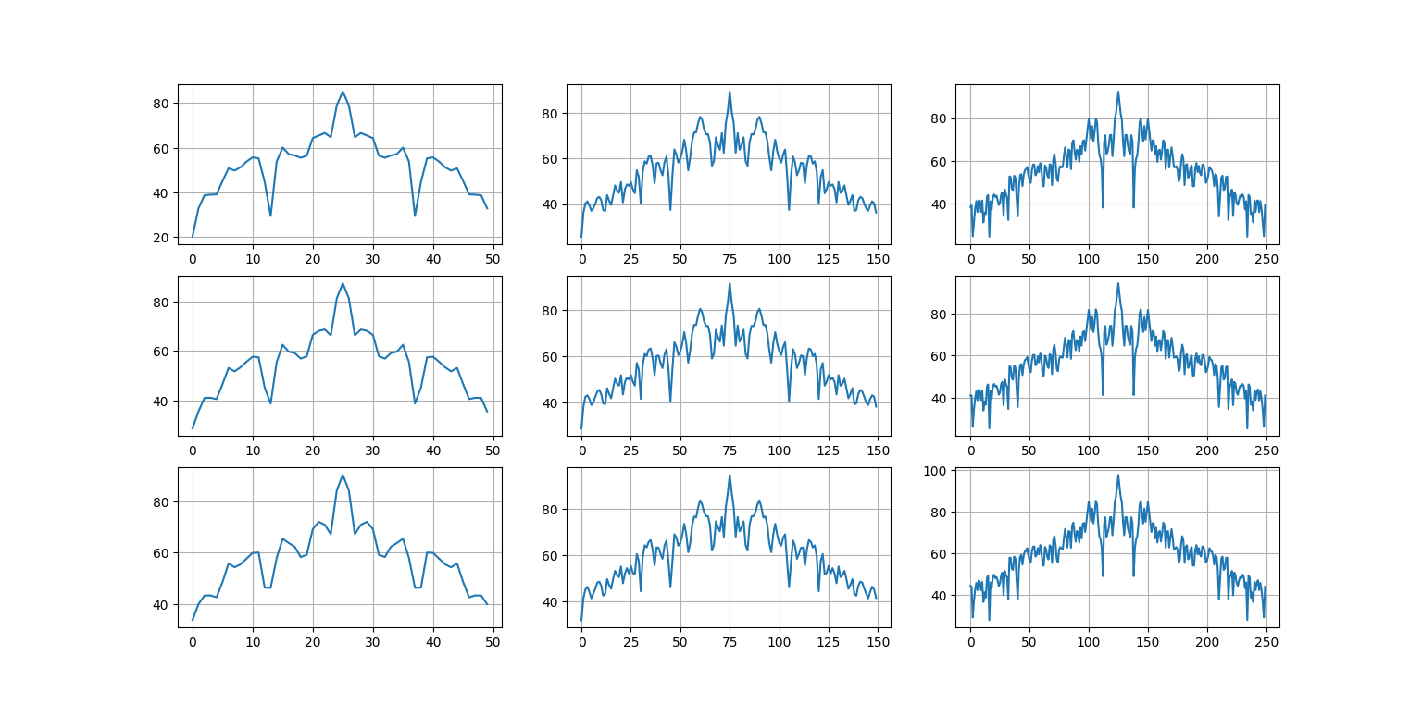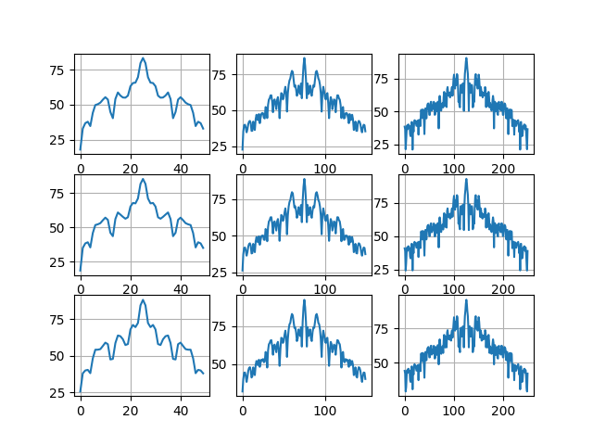

**Observations:**

1. The PSD obtained from the single channel of EEG, it has very high variance
2. The average PSD, helps to smooth out the PSD compared to the PSD of the complete signal.
3. As we increase the number of segments used for averaging, we get more smooth actually PSD
4. But the smoothness comes at the cost, i.e. as the number of segments are increasing , the size of the window is decreasing, and therefore the frequency resolution is decreased
5. If we are having more and more segments and thereby the window size keeps on decreasing, the peaks can get merged.
6. Apart from the peak at the dc, we have peaks in between that 9 to 10 hertz that clearly indicates the presence of alpha rhythm
7. For the rectangular window, we have smaller main lobe and because of that we are getting sharper peaks. And compared to the hamming window, which has lower side lobes compared to the rectangular window, it is giving more smoothing.